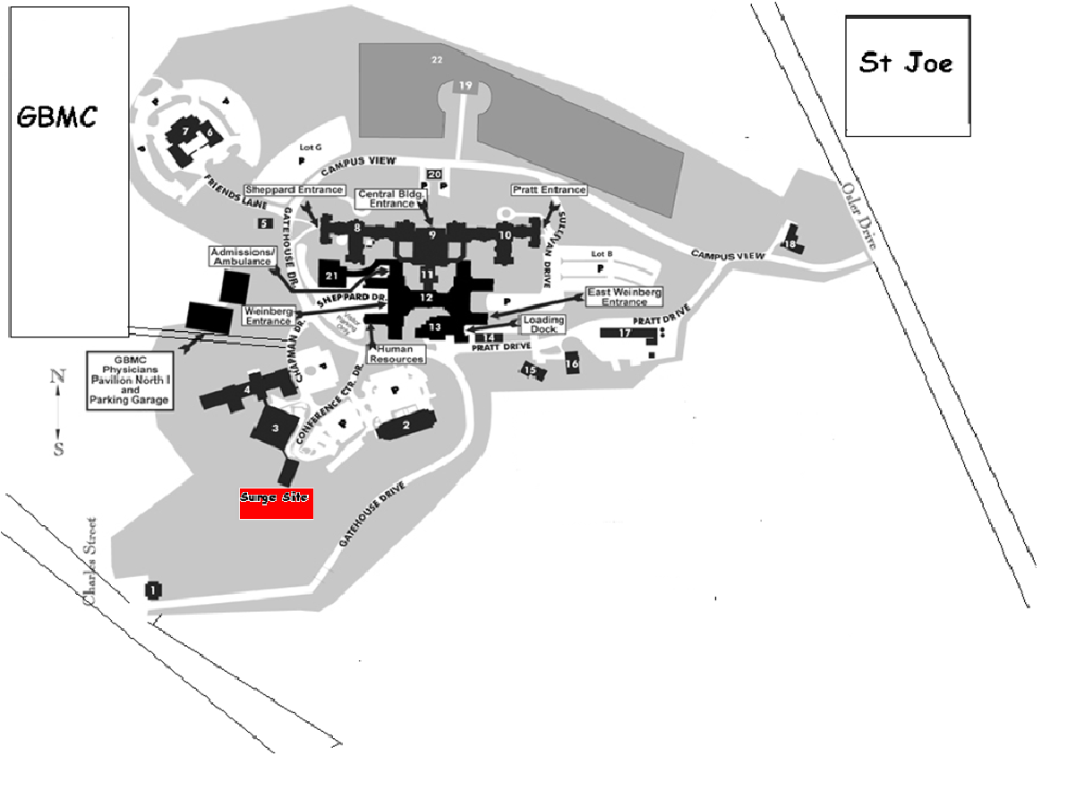
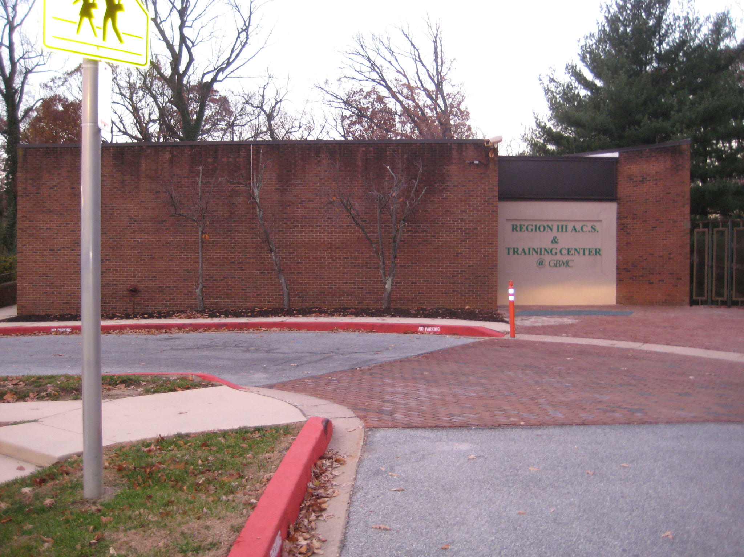

Region III ACS is located adjacent to the GBMC main campus located at 6701 North Charles St, Baltimore.
Please enter using one the following entrances.

Gatehouse Drive off of Charles St, ¼ mile south of the Main GBMC Entrance: Follow road around until you see signs for the Conference Center on your left. Upon entering the Conference Center Lane you will see the ACS to your right. There is a large parking lot in front of the building.
Please follow the signs which will be located in front of the ACS as to the entrance to the building.
Entrance #2 is Campus View Drive off of Osler Drive: You will follow the road a very short distance until you see the sign for Pratt Drive on your left. Take Pratt Drive until you see the sign for the Conference Center on the left. Then follow the same parking procedures listed above.
Parking is Free!

