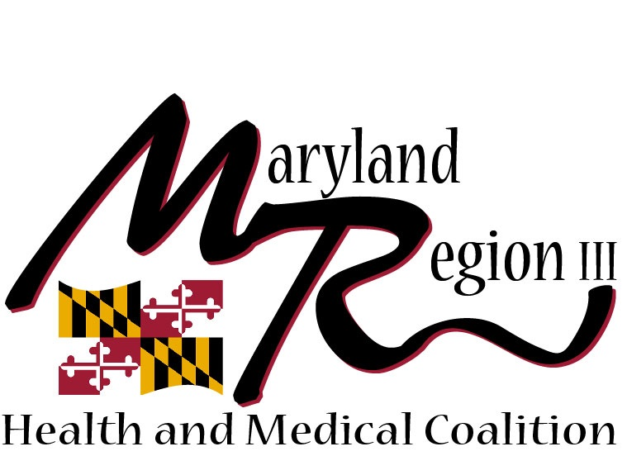

Region III Health and Medical Coalition Welcome Packet
A Regional Healthcare Preparedness Coalition serving Baltimore City and the counties of Anne Arundel, Baltimore, Carroll, Harford, Howard, and Annapolis
Region III Chair: Christina Hughes
HPP Regional Coordinator: kathleen long
Maryland Health and Medical Regions
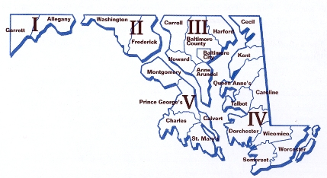
Region III
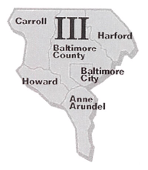
Annapolis

Table of Contents
- General Information p.3
- Region III Health and Medical Coalition (p.3)
- Hospital Preparedness Program Overview (p.3)
- Urban Areas Security Initiative Overview (p.4-5)
- Activities and Events for 2016 p.6
- Coalition 2016 Meeting Calendar (p.6)
- Coalition Subcommitees (p.7)
- Ongoing Projects (p.8)
III. Regional Aid Memorandum of Understanding…………………………..p.9
-Regional Mutual Aid Memorandum of Understanding (MOU) (p.9)
IV. Contact Information p.10

Section I

Region III Health & Medical coalition
The Region III Health & Medical Coalition (previously called the Region III Health & Medical Task Force) was established in 2006 as a planning body devoted to addressing emergency preparedness issues facing the healthcare system in Region III. Maryland Region III consists of Baltimore City and the counties of Anne Arundel, Baltimore, Carroll, Harford, and Howard. Within this area there are 21 acute care hospitals, 7 Federally Qualified Health Centers (FQHCs), 6 DHMH State Facilities, 7 EMS jurisdictions, and 6 local health departments — not to mention many other healthcare providers, including urgent care facilities, long term care/skilled nursing facilities, and countless private providers. The Region III Health & Medical Coalition meets regularly to plan and allocate funding for initiatives related to public health and medical emergency preparedness. The group also assists in establishing priorities for future activities, and collaborates to improve disaster response capabilities throughout the region. Through this Coalition, Region III will become a more resilient community.

Current Initiatives
- Region III Health & Medical Coalition Development
- Resource Management Plan Sustainment
- Allocation of Scarce Resources
- Hospital-Wide Evacuation
- Medical Surge Planning/Exercise
- Alternate Care Site Plan Development
- Active Assailant Kit Distribution

Hospital Preparedness Program (HPP) Overview
The Hospital Preparedness Program provides leadership and funding to States, Territories, and eligible municipalities to improve surge capacity and enhance hospitals and other healthcare systems preparedness for public health emergencies. The funds are distributed to state and territory departments of public health to support the building of healthcare capabilities in the “Healthcare Preparedness Capabilities: National Guidance for Healthcare Systems Preparedness” document.

Healthcare Preparedness Capabilities:
Healthcare System Preparedness
Healthcare System Recovery
Emergency Operations Coordination
Information Sharing
Medical Surge
Fatality Management
Responder Safety and Health
Volunteer Management

Funding for Maryland is administered by the Maryland Department of Health and Mental Hygiene Office of Preparedness and Response. These funds help the state and local government, healthcare coalitions, ESF#8 and other healthcare partners identify gaps in preparedness, determine specific priorities, and develop plans for building and sustaining the 8 national healthcare specific capabilities. These activities support building community preparedness and resilient healthcare systems preparedness for all hazard events.

While HPP continues to encourage preparedness at the hospital level, evidence and real-world events have illustrated that hospitals cannot be successful in response without robust community healthcare coalition preparedness, thus the need to engage other critical partners. Critical partners include but not limited to emergency management, public health, mental-behavioral health providers, as well as community and faith-based partners. Together these partners make up a community’s Healthcare Coalition. A key goal of HPP moving forward is to strengthen the capabilities of the healthcare coalition, member organization, not just the hospital. Healthcare Coalitions are a cornerstone for the HPP and an integral component for community-wide planning for healthcare resiliency.

Urban Areas Security Initiative (UASI) Overview
The Urban Areas Security Initiative program allocates funding every year to enhance regional preparedness in major metropolitan areas throughout the United States. The UASI program directly supports expanding regional collaboration and is meant to assist participants in their creation of regional systems for prevention, protection, response, and recovery. Again, in correspondence with the 9/11 Act, states are required to ensure that at least 25 percent of appropriated funding is dedicated to terrorism prevention planning, organization, training, exercise, and equipment. State Administrative Agencies (Department of Public Safety, State Office of Homeland Security, Emergency Management Agency, etc.) are the only groups eligible to apply directly to FEMA for UASI grants.
The Baltimore UASI region encompasses over 2.7 million residents, and includes Baltimore City (core city), City of Annapolis, and the counties of Anne Arundel, Baltimore, Carroll, Harford, and Howard.

Maryland’s risk from natural or man-made disaster is derived from the unique interplay of the state’s weather, economy, demographics, and geography.

Non-Natural Hazards - For its size and population, Maryland bears a disproportionate risk exposure to deliberate acts of terrorists. Targets include federal and private sector facilities of national and international import. These range from the National Security Agency to the Port of Baltimore and Baltimore/Washington International Airport.

Maryland’s role as a major air, land and sea transportation hub also brings with it concomitant responsibilities to track hazardous cargoes and respond decisively in event of an incident involving in transit hazardous materials.

Natural Hazards - Maryland's most significant natural risk is the landfall of a hurricane on its shores. The risk of harm from storms and flooding is significant because Maryland’s shorelines are densely populated and particularly susceptible to tidal surges and inland flooding due to their limited elevation and the funneling effect of the Chesapeake Bay.

Technological Hazards – Technological hazards for Maryland are both diverse and challenging. Of note is the presence of several nuclear power plants within and outside state borders and a major liquid natural gas terminal.

Recent incidents in the Baltimore UASI region:
Earthquake (5.8 magnitude) – August 23, 2011 Active Shooter (Student in High school) – August 27, 2012 Active Shooter (Johns Hopkins Hospital) – September 16, 2010 Hurricanes – Isabel, 2003; Irene, 2011; Sandy, 2012 Derecho – June, 2012 Tornado – November 16, 2010 Blizzard/Winter Storm – February, 2010 (multiple) Man-made threats – (Law Enforcement sensitive)

Section II

2017 MEETING CALENDAR
Region iii health and medical Coalition

Monday, January 9th
Monday, February 13th
Monday, March 13th
Monday, April 10th
Monday, May 8th
Monday, June 12th
Monday, July 10th
Monday, August 14th
Monday, September 11th
Tuesday, October 10th
Monday, November 13th
Monday, December 11th

Coalition Subcommittee

Ongoing projects

- Allocation of Scarce Resources:
-Projects lead: Howie Gwon
- Communication/IT:
-Projects lead: Tom Jeffers
- HPP Grants:
-Project lead: Kathleen Long
- MIEMSS:
-Project lead: Lisa Chervon/ Jeff Huggins
- Prophylaxis:
-Projects lead: Debra Curro
- Triage Tags:
-Projects lead: Christina Hughes
- UASI – THIRA:
-Projects lead: Cal Bowman
- Ventilators:
-Projects lead: Todd Dousa

SECTION III

Regional Mutual Aid memorandum of understanding
As in other parts of the nation, Region III is susceptible to disasters, both natural and man-made, that could exceed the resources of any individual facility. The possibly of an act of terrorism in the region is considerably higher than other places in the United States due to its geographic proximity to important government, military and high profile public institutions. A disaster could result from incidents generating an overwhelming number of patients, or a smaller number of patients whose specialized medical requirements exceed the resources of the impacted facility.
The Region III Health and Medical Coalition and its partners have signed an MOU that is an agreement to aid healthcare facilities in their emergency management by authorizing the Healthcare Facilities Mutual Aid System (HFMAS), which address the loan of medical personnel, pharmaceuticals, supplies, and equipment, or assistance with emergent healthcare facility evacuation, including accepting transferred patients. The MOU adopted by Region III healthcare facilities for the purpose of providing mutual aid at the time of a medical disaster. Through this document, the Region III partners augment each facility’s disaster plan or MOUs between or among healthcare systems.
The MOU also provides the framework for healthcare facilities to coordinate as a single HFMAS in actions with the Regions Health Department’s Office of Public Health Preparedness and Response, and supplements the rules and procedures governing interaction with other organizations during a disaster.
By signing the Region III MOU, each healthcare facility is stating its intent to undertake a reasonable effort to abide by the terms of the MOU in the event of a medical disaster as described above. The terms of the MOU are to be incorporated into the healthcare facility’s Emergency Management plans.

SECTION IV

Contact Information

Region III Health & Medical Coalition

Agency | Member | Phone | Email | Alternate | Alt Phone | Alt Email
AA County Health | Debbie Saylor | 410-222-4495 | Hdsayl99@aacounty.org | Debra Curro | 410 222-7187 | Hdcurr11@aacounty.org
Annapolis Fire/EMS | Dan Grimes | 410 263-7978 | dagrimes@annapolis.gov | Richard Butler | 443-336-2949 | rdbutler@annapolis.gov
Anne Arundel County Hospitals | Patty Sherman | 443-481-1297 | psherman@aahs.org | Marsha Hora | 410-553-2926 | mhora@bwmc.umms.org
Anne Arundel Fire/EMS | James Wilkison | 410-222-8398 | Fdwilk10@aacounty.org | Mark Dubel | 443-534-6417 | fddubel@aacounty.org
Balt. City Health | Kim Eshleman | 443-984-2620 | Kimberly.eshleman@baltimorecity.gov | Jennifer Martin | 443 984-2618 | jennifer.martin@baltimorecity.gov
Baltimore City Fire/EMS | Mark Fletcher | 410.365.2339 | mark.fletcher@baltimorecity.gov | Jim Matz | 410-365-6212 | james.matz@baltimorecity.gov
Baltimore City Hospitals (Hopkins) | Howie Gwon (Vice Chair) | (410) 502-6122 | hgwon@jhmi.edu | Dianne Whyne | 410-735-6438 | dwhyne@jhmi.edu
Baltimore County Fire/EMS | Christian Griffin | (410) 887-4860 | Cgriffin@Baltimorecountymd.gov | Shift Commander | 410 887-4860 | rschenning@baltimorecountymd.gov
Baltimore County Health | Terry Sapp | 410-887-2428 | tsapp@baltimorecountymd.gov
Baltimore Co Hospitals (Franklin Sq) | Christina Hughes (Chair) | 443-777-7380 | christina.hughes@medstar.net | Loreal Froat | 443-777-2479 | loreal.froat@medstar.net
Carroll CCVESA | David Coe | 443-375-0642 | dcoe@nwfd10.org | Curtis Wiggins | 410-848-1488 | emstc@ccvesa.org
Carroll County Health | Cheryl Webb | 410-876-4817 | Cheryl.webb@maryland.gov
Carroll County Hospitals | Tom Jeffers | 410 871-6756 | TJeffers@carrollhospitalcenter.org | Joe Brown | 410-887-4860 | jbrown@baltimorecountymd.gov
DHMH State Facilities | TBD |  |  | Al Romanosky | 410-767-6631 | al.romanosky@maryland.gov
Harford County EMS | Linda Dousa | 410-808-1553 | ldousa@verizon.net
Harford County Health | Lisa Swank | 410 877-1028 | lisa.swank@maryland.gov | Susan Kelly | 410-877-1010 | susan.kelly@maryland.ogv
Harford County Hospitals | Karen Goodison | 443-643-2327 | KGoodison@uchs.org | Amy Myers | 443-643-3120 | amyers@uchs.org
Howard County DFRS | Jimmy Brothers | (410) 313-0649 | jbrothers@howardcountymd.gov | Mike Stoner | 443-398-0484 | fd2184@howardcountymd.gov.
Howard County Health | Lee Cornwell | 410-313-6306 | hcornwell@howardcountymd.gov | Shantu Scatliffe | 410-313-6293 | sscatliffe@howardcountymd.gov
Howard County Hospitals | Gene Mellin | 410 740-7617 | gmellin@jhmi.edu
Region III EMS Council | Alex Perricone | 443-865-0664 | Alex.perricone@baltimorecity.gov
MHA | Meghan Allen | 443-878-6112 | mallen@mhaonline.org
MEMA | John Dulina | 443 865-8638 | john.dulina@maryland.gov
MIEMSS Reg III | Lisa Chervon | 410-706-3996 | lchervon@miemss.org | Jeff Huggins | 410-706-3996 | jhuggins@miemss.org
MIEMSS Reg III Medical Director | Tim Chizmar | (443) 643-2000 | tchizmar@umem.org
Baltimore UAWG | Cal Bowman | 410 396-6179 | calvin.bowman@baltimorecity.gov | Joe Herr | 410-292-3838 | josephherr@verizon.net
CDC/SNS | TBD
Baltimore VAMC/Veterans Affairs | Dave Csernak | 202-258-8448 | david.csernak@va.gov
Region III ACS at GBMC | Michelle Tauson | 443-849-3036 | mtauson@gbmc.org
DHMH/HPP | Kathleen Long | 443-388-6290 | Kathleen.Long@maryland.gov | Corinne Edds | 410-767-8105 | Corinne.edds@maryland.gov

